SQL ASSIGNMENT -10

ROLL NO-84016

Q1Write a query that produces all pairs of salespeople who are living in the same city.Exclude combinations of salespeople with themselves as well as duplicate rows with the order reversed.
Ans.

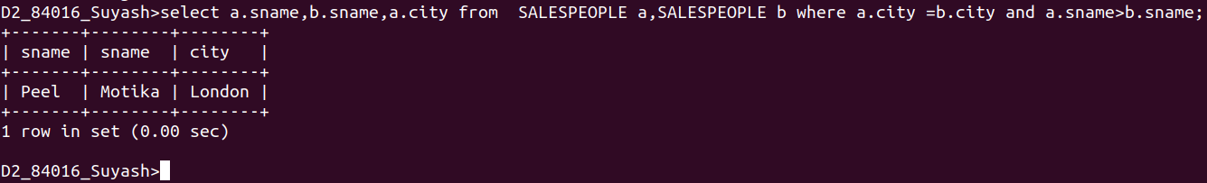
Q2.Write a query that produces the names and cities of all customers with the same rating as Hoffman.
Ans.

